Capstone Project - Preliminary Final Draft

Lily M

July 27, 2016

***INTRODUCTION***

My project studies shifting political sentiment in Silicon Valley using data on individual contributions to presidential election campaigns in the 2008, 2012, and 2016 cycles. Historically, California is a "blue" state; in the 2015-16 cycle to date, the Democratic party and candidates have raked in 58.4% of total contributions while the Republicans have received just 37.7%. But while Silicon Valley has leaned left in every presidential election going since 1984, data through the end of 2015 shows that contributions to Republicans from employees of several major tech firms (Cisco, Oracle, Yahoo, Intel) has so far outstripped money flowing to Democrats in the 2016 cycle. Indeed, while Trump's campaign received just 115 total contributions from the Valley through May (roughly 70 individual contributions) workers, analysis of past election cycles indicates Valley support for Republicans overall is not unsubstantial[1] and may be growing.

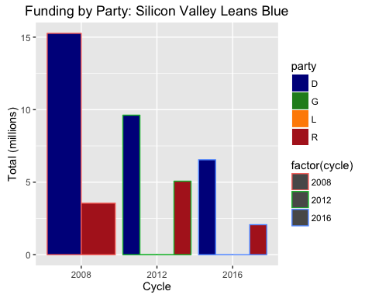

Articles on the volume (ibtimes.com) and breakdown of individual contributions abound in the popular press, but most examine presidential campaign funding in light of data from a single quarter or cycle. Silicon Valley is demographically dynamic and, by reputation, not very ideological, and fully understanding the opportunities for a specific political party means examining sentiment in recent historical context. This project serves as an initial analysis, and raises questions for deeper and more directed study down the road.

I look at data over the past three election cycles to extract overall and zipcode-specific trends. For the purposes of framing the research, my project takes as its client the California Republican Party. Faced with an uphill battle, leaders from the party focused on Silicon Valley want to improve fundraising efforts by directing marketing expenditures to those areas in which they have, on average over the past three presidential election cycles, sourced the lowest amounts of funding and for which funding declined in 2016 (to date) versus 2008. In addition, it would behoove leaders managing party resources to know in which zipcodes their popularity (measured by either contribution frequency or amount received) is growing. This report seeks to answer these questions.

I test several assumptions about the relative breakdown of contribution levels from Silicon Valley, and then compare 2016 giving to date with that during a similar time frame in the 2008 cycle. While the relative sums and frequencies of contributions to Republicans between these two periods reveals several interesting observations itself, I also use it to identify zipcodes demanding promotional efforts by the Republican party. Based on a segment of the 2008 cycle roughly equivalent to the 2016 cycle to date, I identify zipcodes for which funding to Republicans has declined the most across election cycles, on both absolute and frequency terms. Finally, I offer several hypothesis behind the finding that while Republican contributions have remained roughly equivalent across the two periods, the frequency of contributions to Republican candidates has risen dramatically from 2008 to 2016.

***DATA***

**Background**

I use the FEC’s official data on presidential campaign contributions from a list of Silicon Valley zip codes for 2008, 2012, and 2016 election cycles. The data can be found by entering specific zip codes here: [http://www.fec.gov/disclosurep/pnational.do#](http://www.fec.gov/disclosurep/pnational.do). I have identified 75 zip codes comprising the “Silicon Valley” area, summarized in the table on the Appendix.

Examining contributions from the full list of zipcodes reveals major discrepancies and patterns among the political sentiment and contribution volume of different zip codes. Additionally, combining data from the individual zip codes provides a new dataset ripe for future analyses of Valley giving (most available datasets compile zipcode-level data for a specific election cycle, or a less defined set of zipcodes).

**Cleaning & Wrangling**

For each contribution, the FEC data provides information on the candidate name (cand_nm_title), contributor name (contbr_nm), contributor city (contbr_city), contributor state (contbr_st), contributor zip (contbr_zip), contributor employer (contbr_employer), transaction description (receipt_desc), contribution date (contb_receipt_dt), and amount given (contb_receipt_amt). To assign the contribution to a specific party, I created a separate file listing the candidates who ran in the Democratic and Republican primaries in CA in each election cycle, denoting party affiliation. Since the names of candidates in this separate file (with tables from Wikipedia articles on the primaries) did not always match the formatting of names provided through the FEC data, I make several edits to the cand_nm_title variable in the main dataset to ease the merge process.

An initial look at several zip codes showed that in several cases, the contributions recorded were made to candidates who did not ultimately participate in the CA primary (e.g. Jeb Bush in 2016), so this list of primary participants does not capture the full set of recipients included in the dataset. Since this study does not distinguish between candidates that did participate in the primary from those who did not when examining party totals, I manually code the party identification of those candidates missing from the primary file. The table in the Appendix summarizes the candidates receiving money from Silicon Valley in each election cycle, along with a note about whether each was ultimately a candidate in the primary. N.B. Candidates (e.g. Ted Cruz in the 2016 cycle) who had dropped out of the race but appeared on the CA ballot are denoted as in the primary.

The FEC data includes the date of contribution in month-day-year format, so I extract year information to match years with specific election cycles. The full dataset provides the following number of observations in each year.

Cycle Classification

|  |  |  |
| --- | --- | --- |
| Year | Observations | Cycle |
| 2006 | 57 | 2008 |
| 2007 | 10384 | 2008 |
| 2008 | 47401 | 2008 |
| 2011 | 5689 | 2012 |
| 2012 | 57502 | 2012 |
| 2013 | 2 | 2016 |
| 2014 | 17 | 2016 |
| 2015 | 9378 | 2016 |
| 2016 | 27357 | 2016 |

I classify contributions given in 2006, 2007, and 2008 as part of the 2008 cycle, contributions from 2011 and 2012 as part of the 2012 cycle, and contributions from 2014, 2015, and 2016 as part of the 2015 cycle. The variable year_cycle is coded categorically to retain this information.

An initial look at the contribution amounts produced some puzzling observations, because the individual contributions denoted are in some cases negative. Digging deeper into the source of these negative values, I examine the description (‘receipt_desc’) variable. The negative values relate to contribution limits.[2] Campaign treasurers must regularly check committee records to ensure the total amounts donated by one contributor remain within the legal limits ($2300 for 2008, $2500 for 2012, and $2700 for 2016). Many of the categories are tools to handle excessive contributions. While committees may deposit the excessive amount from a contribution, they must seek the contributor's *reattribution* of the portion to a joint contributor (e.g. reattribution from spouse, reattribution/redesignation requested) or the contributor's *redesignation* of the portion for a different election (redesignation from primary, redesignation to general) for which the contributor hasn't already exceeded limits. The "redesignation from" and "redesignation to” lines cancel each other out, so there is no need to remove these categories from the dataset: "REDESIGNATION TO", "REATTRIBUTION/REDESIGNATION REQUESTED", "REDESIGNATION FROM", "REDESIGNATION TO GELAC", "REDESIGNATION FROM PRIMARY", "REDESIGNATION REQUESTED", "REDESIGNATION TO GENERAL", "REDESIGNATION FROM GENERAL", "REDESIGNATION TO PRIMARY DEBT.” We keep the data on refunds ("redesignation from primary; refund to be issued") in the dataset to glean insight into the total amount given by each individual. As for the reattribution categories, "reattribution from spouse" represents new money to the candidate, although it may be coming from another individual, and hence must be included. As will be seen, this method of handling alternative contribution types means that for certain zipcodes the sum of contributions to Republicans in a given cycle is negative, since the refunds outweigh the new giving.

***ANALYSIS: SILICON VALLEY FUNDING TRENDS***

With a cleaner dataset, I began my analysis by testing several simple assumptions about the balance of contributions in Silicon Valley. These assumptions are based on preconceived notions of the Bay Area political spectrum, touched on briefly above, and will help clarify the party balance of funding from the Valley. Tables on the totals and contribution frequency to Republicans and Democrats in each election cycle enable a test of these assumptions, and also reveal several other observations.

Contribution Sums & Shares, by Party-Cycle

|  |  |  |  |  |
| --- | --- | --- | --- | --- |
| Cycle | Party | Total Received ($) | Cycle Share to Party (%) | total_scaled |
| 2008 | D | 15264542 | 81.1244327 | 15.264542 |
| 2008 | R | 3551666 | 18.8755673 | 3.551666 |
| 2012 | D | 9619654 | 65.4166736 | 9.619654 |
| 2012 | G | 9437 | 0.0641746 | 0.009437 |
| 2012 | L | 7705 | 0.0523964 | 0.007705 |
| 2012 | R | 5068406 | 34.4667554 | 5.068406 |
| 2016 | D | 6545910 | 75.9215884 | 6.545910 |
| 2016 | G | 4727 | 0.0548253 | 0.004727 |
| 2016 | L | 942 | 0.0109256 | 0.000942 |
| 2016 | R | 2070356 | 24.0126607 | 2.070356 |

***1. Democrats received more than Republicans in 2008.***

True - Democrats received more funding ($17,084,595) than Republicans ($3,924,460) from these zipcodes in the 2008 cycle.

***2. Democrats received more than Republicans in 2012.***

True - this assumption also holds, with Democrats receiving $11,113,302 and Republicans receiving $5,619,220, although notably the discrepency between Democratic and Republican fundraising is much smaller than it was for 2008. The gap's shrinkage appears to be primarily due to a 35% fall in funding to Democrats, and a 43% rise in funding to Republicans, understandable given the lack of a CA presidential primary for Democrats in 2012 as Obama was the incumbent president.

***3. Democrats have so far received more than Republicans in 2016.***

True - So far in the 2016 cycle, Democrats have so far received $7,482,578 while Republicans have received just $2,322,685. Notably, however, the share of total contributions captured by Republicans has grown from 19% in the 2008 cycle to 34% in the 2012 cycle, and currently stands at 24% in 2016.

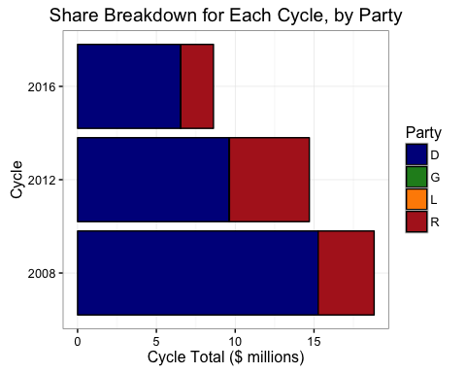

***4. There are more contributions to Democrats than Republicans in each cycle.***

True - Democratic contributions reached 49,956 in 2008 versus 6,919 for Republicans. For 2012, Democrats received 50,633 contributions while Republicans received 8,807. For 2016, Democrats have so far received 42,471 contributions while Republicans stand at 8,247. Admittedly, these numbers do not take repeat observations into consideration - in some cases, the reattributions cause certain contributors to be listed twice, and as we'll note in examining contribution frequency later on, the name of one contriibutor may be formatted differently at different parts of the cycle (e.g. with a MR/MRS, or without). While these do not affect the contribution sums, since the negative values act as a balance, they do interfere with an accurate gauge of contribution frequency. But regardless, the observation totals show Democrats have received far more individual contributions than Republicans in past cycles.

***5. Contributions to both major parties so far in 2016 hasn't reached the levels of 2008 or 2012.*** Giving to Democrats is so far at just 43% and 67% of 2008 and 2012 levels, while that to Republicans is similarly at just 59% and 41% of the sums from the two former cycles. As the cycle-on-cycle comparison illustrates, the timeline of giving is likely a factor when comparing sums of giving across cycles, as the 2016 cycle is not yet over. When examining giving totals by month, we find that some of the months with the highest levels of giving have not yet occured in the 2016 cycle. For Democrats, the month of highest giving was September of the election year in both 2008 and 2012 - which has not yet occured in the 2016 cycle. For Republicans, the second-highest giving was in August of the election year in 2008 and the top three giving months were June, September, and October of the election year for the 2012 cycle - all of which are not represented in the 2016 data.

New Giving by Month to Republicans, 2008

|  |  |  |  |  |  |  |
| --- | --- | --- | --- | --- | --- | --- |
|  | Month | Year | Cycle | Party | Total Received ($) | Cycle Share to Party (%) |
| 22 | 3 | 2007 | 2008 | R | 407331 | 11.8369261 |
| 29 | 1 | 2008 | 2008 | R | 334356 | 9.7162928 |
| 32 | 8 | 2008 | 2008 | R | 309516 | 8.9944493 |
| 36 | 9 | 2007 | 2008 | R | 273050 | 7.9347574 |
| 48 | 5 | 2008 | 2008 | R | 241297 | 7.0120240 |
| 50 | 6 | 2008 | 2008 | R | 239226 | 6.9518414 |
| 54 | 12 | 2007 | 2008 | R | 227409 | 6.6084426 |
| 58 | 6 | 2007 | 2008 | R | 208536 | 6.0599984 |
| 72 | 7 | 2008 | 2008 | R | 171591 | 4.9863870 |
| 77 | 11 | 2007 | 2008 | R | 152379 | 4.4280916 |
| 82 | 4 | 2008 | 2008 | R | 137749 | 4.0029478 |
| 95 | 1 | 2007 | 2008 | R | 110675 | 3.2161849 |
| 97 | 2 | 2007 | 2008 | R | 107310 | 3.1183989 |
| 103 | 7 | 2007 | 2008 | R | 91048 | 2.6458297 |
| 105 | 5 | 2007 | 2008 | R | 88545 | 2.5730932 |
| 109 | 8 | 2007 | 2008 | R | 80150 | 2.3291368 |
| 114 | 9 | 2008 | 2008 | R | 72025 | 2.0930266 |
| 125 | 10 | 2007 | 2008 | R | 54872 | 1.5945651 |
| 126 | 3 | 2008 | 2008 | R | 50934 | 1.4801279 |
| 131 | 4 | 2007 | 2008 | R | 41414 | 1.2034794 |
| 139 | 10 | 2008 | 2008 | R | 34150 | 0.9923895 |
| 149 | 12 | 2006 | 2008 | R | 10100 | 0.2935032 |
| 154 | 12 | 2008 | 2008 | R | 4900 | 0.1423926 |
| 155 | 11 | 2006 | 2008 | R | 3570 | 0.1037432 |
| 156 | 11 | 2008 | 2008 | R | 2975 | 0.0864527 |
| 171 | 2 | 2008 | 2008 | R | -13919 | -0.4044823 |

New Giving by Month to Republicans, 2016

|  |  |  |  |  |  |  |
| --- | --- | --- | --- | --- | --- | --- |
|  | Month | Year | Cycle | Party | Total Received ($) | Cycle Share to Party (%) |
| 13 | 6 | 2015 | 2016 | R | 296144 | 15.3344045 |
| 19 | 9 | 2015 | 2016 | R | 263532 | 13.6457476 |
| 23 | 12 | 2015 | 2016 | R | 226327 | 11.7192642 |
| 33 | 7 | 2015 | 2016 | R | 172828 | 8.9490736 |
| 42 | 8 | 2015 | 2016 | R | 140013 | 7.2499054 |
| 47 | 2 | 2016 | 2016 | R | 135466 | 7.0144607 |
| 52 | 10 | 2015 | 2016 | R | 129747 | 6.7183295 |
| 56 | 11 | 2015 | 2016 | R | 120624 | 6.2459385 |
| 67 | 3 | 2016 | 2016 | R | 102702 | 5.3179332 |
| 68 | 1 | 2016 | 2016 | R | 101968 | 5.2799265 |
| 79 | 5 | 2015 | 2016 | R | 82691 | 4.2817590 |
| 85 | 4 | 2016 | 2016 | R | 70484 | 3.6496777 |
| 110 | 4 | 2015 | 2016 | R | 44911 | 2.3255019 |
| 135 | 3 | 2015 | 2016 | R | 21402 | 1.1082005 |
| 145 | 5 | 2016 | 2016 | R | 11460 | 0.5934014 |
| 150 | 9 | 2014 | 2016 | R | 5190 | 0.2687394 |
| 151 | 12 | 2014 | 2016 | R | 4100 | 0.2122989 |
| 158 | 7 | 2014 | 2016 | R | 1000 | 0.0517802 |
| 161 | 1 | 2015 | 2016 | R | 600 | 0.0310681 |
| 169 | 2 | 2015 | 2016 | R | 50 | 0.0025890 |
| 170 | 11 | 2013 | 2016 | R | 0 | 0.0000000 |

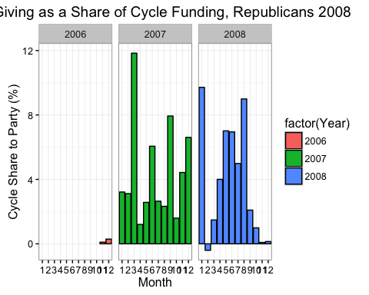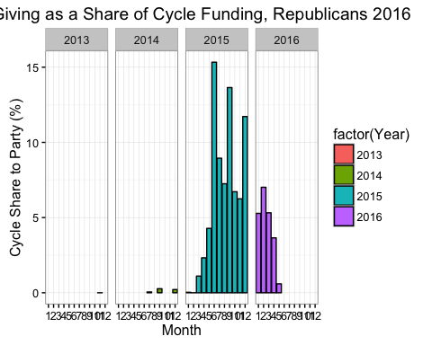

As noted earlier, the monthly sums occasionally result in negative values, which are attributable to reattributions/redesignations or refunds that transpired in a given month. To examine monthly giving on the basis of purely NEW giving, I temporarily ignore these categories in the dataset - reflected in the graphs above.

***COMPARATIVE ANALYSIS - Prorated 2008 vs 2016***

***Preliminary Analysis of Data***

To explore the role the timeline of giving may play in the magnitude and breakdown of contribution levels, we compare 2016 giving levels with the segment of 2008 giving that corresponds to the 2016 cycle to date. Comparing these two segments provides the fairest comparison in the realm of recent presidential elections, since both cycles follow a two-term presidency and therefore do not involve an incumbent. The earliest recorded contribution for 2016 from the Silicon Valley zipodes under analysis is July 25th, 2014 - slightly later than the first contribution recorded for the 2008 cycle, from April 12th, 2006. For the purposes of this analysis, we examine contributions related to the 2016 cycle through May 31, 2016. This means that we have 677 days of contribution data for the 2016 cycle. In order to set up a fairer comparative analysis between the 2008 and 2016 cycles, we subset this segment of days from the total number for the 2008 cycle (995 days). This means that we restrict the data under examination for 2008 from April 12, 2006 to the date 677 days later, February 18th, 2008.

Funding by Party, 2016 vs Prorated 2008

|  |  |  |  |
| --- | --- | --- | --- |
| Cycle | Party | Sum | Share of Cycle Total (%) |
| 2008 | D | 6569892 | 73.3370549 |
| 2016 | D | 6545910 | 75.9215884 |
| 2016 | G | 4727 | 0.0548253 |
| 2016 | L | 942 | 0.0109256 |
| 2008 | R | 2388597 | 26.6629451 |
| 2016 | R | 2070356 | 24.0126607 |

The comparable subsets of the data enable a fairer comparison of Republican giving across the 2008 to 2016 cycles. We already know that Democrats have so far received more than Republicans for the 2016 cycle, but we reexamine the contribution totals for the subset period of 2008. Analysis shows that the assumption that Democrats received more than Republicans in 2008 holds true for the prorated subset of 2008 as well as for the full cycle - Democrats received $7,209,363 while Republicans received $2,604,544 in this early segment.

***1) Relative to a similar point in the 2008 cycle, has funding to Republicans increased in 2016?*** No - Republicans have so far captured a roughly equivalent level of funding ($2,322,685) as they had at a similar point in the 2016 cycle ($2,604,544).

***2) Relative to a similar point in the 2008 cycle, has the share of funding captured by Republicans increased in 2016?*** No - relative to the 27% of total funding they captured in the prorated segment of the 2008 cycle, the share of funding to Republicans has fallen to 24% in 2016.

***3) Has the number of Republican contributors in Silicon Valley increased from 2008 to 2016?***

Contributions to Republican Candidates

|  |  |  |  |  |
| --- | --- | --- | --- | --- |
|  | D | G | L | R |
| 2008 | 12669 | 0 | 0 | 3878 |
| 2016 | 30754 | 54 | 4 | 5942 |

The table on contribution frequency for each party (R, D, L, G) shows that the number of Republican contributions in 2016 so far is nearly double that for a similar point in the cycle in 2008. While Silicon Valley data shows just 4,619 contributions to Republicans in the prorated segment of 2008, there have been 8,331 contributions recorded for 2016 so far. Admittedly, this is the total number of recorded contributions - including repeat contributions by the same individual, and the reclassifications mentioned earlier. Attempting a gauge of individual contributions is difficult using FEC data, since some names are recorded differently across different cycles (for instance, with or without a "MR." or "MRS."). Further research is necessary to identify unique contributors, but a gauge (in R, using the contbr_nm variable) shows roughly 2,246 unique individual contributors to Republicans in 2016 (8,331 total observations) and 2,441 individual contributors in 2008. The simultaneous rise in contributions and fall in unique contributions hints that the contribution frequency per individual has increased across the cycles - a similar number of individual contributors is responsible for nearly double the contributions in 2016 than they were for in 2008. Additionally, the simultaneous stability of the sum contributed to Republicans across zipcodes in each cycle and the rise in contribution frequency indicates that the amount of each contribution has declined.

In 2008, there were an average of 62 contributions to Republicans recorded per Silicon Valley zipcode, with a max of 325, while in 2016 so far the average stands much higher at 110, with a max of 419. Indeed, when we examine the breakdown of contributions by candidate, we find that Ted Cruz has in 2016 individually neared the level of contribution frequency for Republican candidates combined in 2008, and Marco Rubio and Ben Carson have also proved more popular than any other Republican candidate did at the similar stage of the 2008 cycle. Since the sum of funding to Republicans has not changed cycle-on-cycle, however, the rise in contribution frequency suggests that the amount per contribution is declining.

***ZIPCODE-LEVEL COMPARISONS:***

Having tested several basic assumptions about the breakdown of funding in the Silicon Valley area, I turn to an in-depth examination of funding patterns for the Republican party. To frame the analysis, I focus on the following questions:

***Which zip codes saw a decline in the # of individuals contributing to Republicans?*** ***Which zip codes saw a decline in the $ sum contributed to Republicans? Overall, and Normalized.*** ***Which zip codes contributed the least to Republicans? Are these are low contributors overall, or is the balance of funding heavily skewed to the Democrat side?***

Before diving into these specific questions, several insights from initial examination of the total contribution totals by zipcode are worth clarification.

In one case (94302 in the 2016 cycle), the total sum given to a party is negative. A deeper dive reveals that this is due to a large refund ($2,600) from Marco Rubio's campaign to Mark Zuckerberg. There is no record of another contribution to Rubio in the data, which likely indicates a refusal to allow money directed toward a senate campaign to be transferred to Rubio's presential fund. (<http://www.inc.com/tess-townsend/tech-executives-2016-presidential-race.html>). In fact, examining Zuckerberg's further reveals that he gave $2600 to the primary and $2600 to the general campaign of "Marco Rubio for Senate" in September 2013. As discussed before, a refund indicates a reduction of support for a candidate's presendential run. While it may be simplest to limit analysis to positive amounts, this would provide an inflated sum for total contributions, since it would not consider refunds from over-giving (when campaign contribution limits were exceeded). (<http://docquery.fec.gov/cgi-bin/fecimg/?13020434455>, <http://docquery.fec.gov/cgi-bin/fecimg/?13020434450>)

**QUESTION A) Which zip codes saw the biggest decline in the # of individuals contributing to Republicans?**

Republican contributions have risen by 50 on average across the 75 zipcodes, with a standard deviation of 72. There are several zipcodes for which the number has fallen over a full standard deviation below the mean change, including: "94010" "94025" "94027" "94040" "94041" "94043" "94306". Within this group, the number of contributions has fallen by 46 across the cycles. What the graph shows, however, is that those showing the largest declines all saw far more contributions to Republican candidates in 2008 than the average for the dataset. Perhaps the most interesting cases, then, are those in which the 2016 values are far below the average for this cycle so far. These include zip codes 94040, 94041, 94043, and 94306. Looking in depth at 94306, which saw a fall in the number of contributions from above average in 2008 to far below average in 2016, we find that the change is driven by a high number of contributions to Romney (40) and Ron Paul (20) in 2007, while the largest number of contributions in 2016 came to Ted Cruz (22), but no other candidate received more than 8. This indicates that popularity of specific canddiates may be driving a part of the zipcode-level totals observed, prompting further examination of candidate-level sums below.

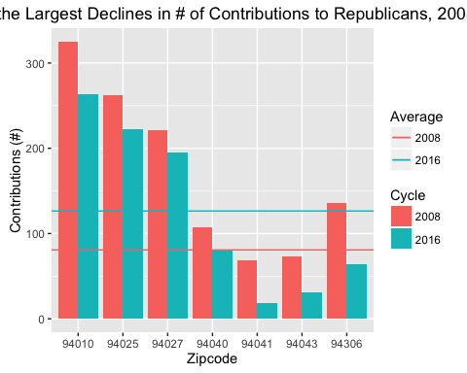

***QUESTION B) Which zip codes saw the biggest decline in the $ sum contributed to Republicans - overall, and normalized by # of contributors?***

Republican contributions have fallen by an average of $3,758 per zipcode across the 75 zipcodes represented in the dataset. There are five zipcodes that saw a dramatic fall in contributions - amounting to a standard deviation below the average change - including "94010" "94025" "94027" "94070" "94301". What we see from the graph, however, is that those showing the largest $-amount declines in funding cycle-on-cycle are all zipcodes for which the 2008 sum was significantly higher than average. Additionally, in all but one case, the 2016 level is also above average. So those showing the largest declines are zipcodes on the higher side of Republican funding in each cycle.

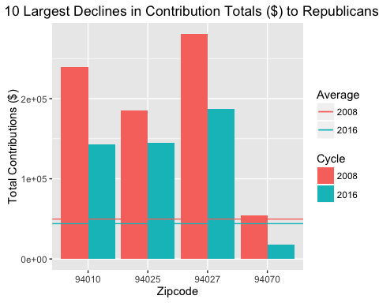

***QUESTION C) Which zip codes contributed least to Republicans? Are these zip codes low-contributors overall, or Democrat-heavy?***

Given that those zipcodes seeing the largest declines in both the number of contributions and the total sum contributed to Republicans are by and large areas in which funding numbers and sums were above average in 2008, it may be more useful to examine which specific zipcodes are the lowest absolute contributors to Republicans in both frequency and monetary amount.

The lowest 10 contributors to Republicans in 2008 were "94011" "94064" "94088" "95111" "95116" "95119" "95121" "95122" "95130" "95139". The average sum contributed to the relevant party in the prorated '08 cycle was just $604.7, relative to the $34,727.25 for the entire dataset. For 2016, the lowest 10 contributors to Republicans were "94011" "94026" "94064" "94302" "95111" "95113" "95116" "95130" "95133" "95139". The average sum contributed to the relevant party in the 2016 cycle to date has been just $432.7, relative to the $30,969.13 for the entire dataset.

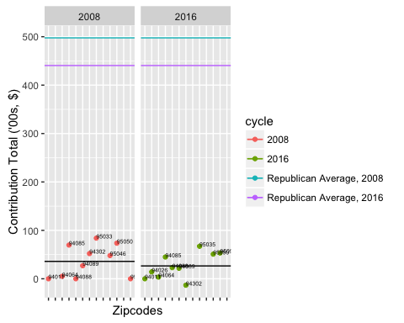

The overlapping zipcodes are 94011, 94064, 95116, 95111, and 95139. These zipcodes were among the lowest contributors in both 2008 and 2016. In the case of 94011, it is because the zipcode has as yet given no money to candidates of either party in 2016, and also gave no money to either candidate in the relevant portion of the 2008 cycle. In the case of 94064, all contributions came after February 2008, and those to Republicans were from a single contributor, to Ron Paul only. The same timeline applied in 2016, with no contributions so far to either party. In 95116, by contrast, we find a case in which the low level of funding to Republicans is not mirrored on the Democratic side in the prorated portion of the 2008 cycle. Just two individuals contributed (nominal) sums to Republican candidates (namely Mike Huckabee and Ron Paul). While it came after February 2008, the majority of contributions from the zipcodewent to Democrats, to Barack Obama. In 2016, the same has happened - the only Republican receiving contributions was Mike Huckabee, who received just $40, from a single donor. By contrast, Democrats have received 254 contributions, totalling $16,102. This means that for the both cycles, the balance of funding from the zipcode went to Democrats. Zipcode 95111 saw just three contributions to Republicans in the earlier part of the 2008 cycle, compared to 41 contributions to Republicans. This disparity became worse as time went on in the cycle, with combined contributions to Democrats standing at 150 relative to the 4 for Republicans. In 2016 we've seen similar patterns, with just 17 contributions to Republicans and 241 to Democrats. In both cycles, Hillary Clinton has captured nearly twice the number of contributions as any other candidate. In the case of zipcode 95139, the majority of contributions came in the latter part of the cycle, with just Barack Obama receiving any money in the prorated portion of the 2008 cycle. His total ultimately went up to 86 contributions ($8,250) relative to John McCain's $1,176, indicating that the zipcode was a low contributor overall (just three candidates total received contributions) but leans Democratic. The same is seen when examining data for 2016. Only 4 of the 89 contributions to date have gone to Republican candidates, with the sum to that party at $591 relative to the $4,611 Democrats have received.

As the graph above indicates, then, the zipcodes representing the lowest contributors to Republicans are not always dominated by Democrats. In four of the five cases in which the zipcode appeared as a bottom 10 contributor in both cycles, the zipcode is contributed relatively nominal sums to both major parties.

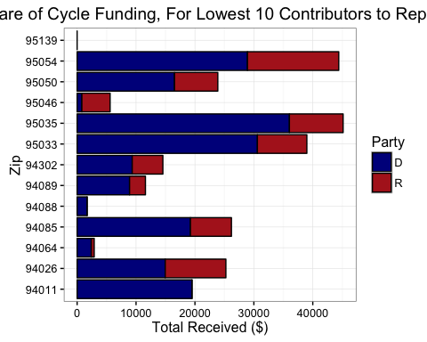

***CONCLUSIONS***

This report has identified the zipcodes in which funding to Republicans has declined cycle on cycle, and those for which funding to Republicans is low relative to the average Silicon Valley giving to the party. We've determined that for the area as a whole, contributions to Republicans have nearly doubled in 2016 from the similar part of the 2008 cycle, but the total amount contributed has remained steady. Since the sum of funding to Republicans has not changed cycle-on-cycle, the rise in contribution frequency suggests that the amount per contribution is declining.

In future studies, it will be useful to explore further how to formulate an accurate gauge of contribution sums given the specific classes of contribution observations (refund, reattribution, redesignation, etc) and to find an optimal way to gauge unique contributors rather than simply unique contributions. The latter will enable a better understanding of whether the number of individuals contributing to the Republican party overall and in different zipcodes is increasing, vital to party leaders drawing strategy maps for where to focus promotional efforts in future cycles.

What also may be interesting to explore is the degree to which personal popularity of specific Democratic or Republican candidates drives trends in party-level giving for the Valley, and the giving patterns of bigger donors. As we can see from the snapshot below, the number of contributions reaching the maximum amount ($2,700) going to Hillary Clinton in the 2016 cycle to date has far outstripped that to any of the Republican candidates (Jeb Bush is the runner up at 135, just one-tenth Hillary's 1,278). Similarly, Democrats led the way in high-level giving in the proportional period of the 2008 cycle, with Barack Obama and Hillary Clinton receiving 1302 maximum-level contributions among them compared to the collective 517 of the top three Republican recipients.

Number of Maximum Contributions ($2300) in Early Part of 2008, by Candidate

|  |  |
| --- | --- |
| Candidate | Contributions of Max Amount |
| Barack Obama | 787 |
| Hillary Clinton | 457 |
| Mitt Romney | 261 |
| John McCain | 122 |
| John Edwards | 120 |
| Rudy Giuliani | 87 |
| Ron Paul | 32 |
| Bill Richardson | 25 |
| Christopher Dodd | 17 |
| Mike Huckabee | 9 |
| Fred Thompson | 8 |
| Sam Brownback | 5 |
| Joe Biden | 4 |
| Dennis Kucinich | 3 |
| Duncan Hunter | 0 |
| Mike Gravel | 0 |
| Tom Tancredo | 0 |
| Tommy G Thompson | 0 |

Number of Maximum Contributions ($2700) in 2016 through June, by Candidate

|  |  |
| --- | --- |
| Candidate | Contributions of Max Amount |
| Hillary Clinton | 1203 |
| Jeb Bush | 130 |
| Marco Rubio | 122 |
| John Kasich | 40 |
| Christopher J. Christie | 34 |
| Carly Fiorina | 23 |
| Ted Cruz | 19 |
| Lindsey O. Graham | 16 |
| Bernie Sanders | 11 |
| Mike Huckabee | 10 |
| Ben Carson | 8 |
| Lawrence Lessig | 6 |
| Scott Walker | 6 |
| Martin Joseph O'Malley | 5 |
| Rand Paul | 3 |
| James R. (Rick) Perry | 2 |
| Donald Trump | 1 |
| Bobby Jindal | 0 |
| Gary Johnson | 0 |
| George E. Pataki | 0 |
| James Henry Jr. Webb | 0 |
| Jill Stein | 0 |
| Rick Santorum | 0 |

1. <http://www.bloomberg.com/politics/articles/2016-02-09/bush-rubio-lure-tech-geek-giving-googler-dollars-back-clinton>
2. <http://www.fec.gov/pages/brochures/contrib.shtml#Presumptive_Redesignations>